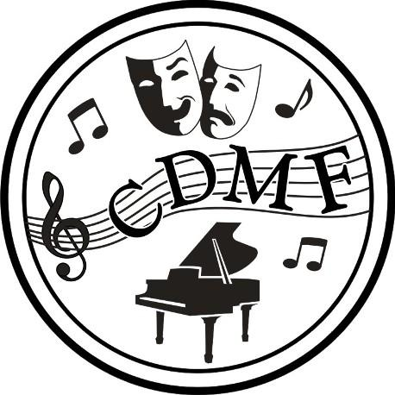
{#class}

2025 CDMF Mark Sheet – Piano

{class_name}
{class_datetime}

{class_datetime} | {class_name} | Mark | Placement
{#participants}{index} | {name} |  | {/participants}

{/class}

